**Multiple Linear Regression**

When there are multiple independent variables (or features) that are used to predict a single dependent variable, it’s known as **Multiple Linear Regression**.

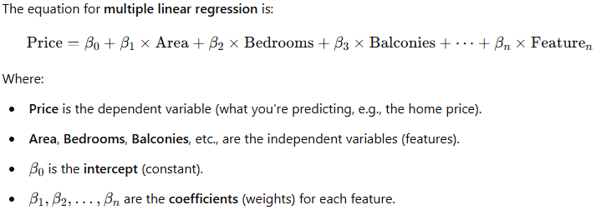

In predicting home prices, you might have:

* **Area** of the house (in square feet)
* **Number of bedrooms**
* **Number of bathrooms**
* **Number of balconies**
* **Location** (could be a categorical feature encoded numerically)
* **Age of the house** (how old it is)

**Coefficients**: Each feature has a coefficient, which represents its impact on the price. A positive coefficient means that as the feature increases, the price increases. A negative coefficient means that as the feature increases, the price decreases.

**Intercept**: This is the base value of the dependent variable when all the independent variables are zero. In practical terms, it's often a fixed cost or baseline value in real-world applications.